

Centre Name: ACE-HCMC-2-FPT (VN.033)

Address: 590 Cách Mạng Tháng 8 Street, District 3, Ho Chi Minh City, Viet Nam



WEB PHOTO

SHARE

Additional Information

|  |  |  |  |
| --- | --- | --- | --- |
| **Faculty:** | | **Mr. Nguyen Ngo Phuoc** |  |
| **Batch No:** | | **F2-10-1203-T0** |  |
| **Group No:** | | **01** |  |
| **Student** |  | **Full Name** | **Roll No.** |
|  | 1. | NGUYEN VU HUNG | STUDENT636555 |
|  | 2. | TRAN VAN HAI | STUDENT630717 |
|  | 3. | LE NGOC NHUT | STUDENT636217 |
|  | 4. | NGUYEN ANH TUAN | STUDENT576665 |

September 2013

# Table of Contents

Table of Contents 2

I. Introduction 3

II. Task Assignment 4

III. Technology 6

IV. Database Design 7

1. Database Relationship Diagram (DRD) 7

2. Database Structure 8

2.1. Table: contact 8

2.2. Table: faqs 8

2.3. Table: feedbacks 9

2.4. Table: collections 9

2.5. Table: users 10

2.6. Table: images 10

2.7. Table: comments 11

2.8. Table: user_friends 11

3. Database Constrains 12

3.1. comments 12

V. GUI Designs – Front-End 13

1. Reset Password Form 13

2. Change Password Form 14

3. Update Profile with Avatar 14

4. View Collection 15

VI. GUI Design – Back-End 16

# Introduction

This document contain addition information for Web Photo Share website project, This include information about the change in design, the change in database structure, the change in used technology… and task assignment for member

We would like to thank sincerely!

Group 1 – FPT Aptech.

# Task Assignment

| No | Task | Assignment | Description |
| --- | --- | --- | --- |
| 1 | Design | Nguyen Vu Hung | Design layouts for website back-end and front-end |
| 2 | Slice HTML/CSS | Nguyen Vu Hung | Slice designed layouts to html/css include javascripts |
| 3 | Implement Default Page | Nguyen Vu Hung | Default page for visitors and un-authenticated users |
| 4 | Implement Login Page | Nguyen Vu Hung |  |
| 5 | Implement Registration page | Tran Van Hai |  |
|  | Implement Login page | Nguyen Vu Hung |  |
| 7 | Implement Forgot Password page | Le Ngoc Nhut |  |
| 8 | Implement Recover password | Le Ngoc Nhut |  |
| 9 | Implement Static Page | Tran Van Hai | About us, Terms & Privacy |
| 10 | Implement User Homepage | Nguyen Vu Hung | Homepage for user after logged in, show the latest and public image |
| 11 | Implement User Profile | Le Ngoc Nhut | View and update user profile |
| 12 | Implement Change Password | Le Ngoc Nhut |  |
| 13 | Implement My Images | Nguyen Vu Hung | View uploaded image, include upload images |
| 14 | Implement Edit Image | Nguyen Vu Hung | Include delete images |
| 15 | Implement Edit Avatar | Nguyen Vu Hung |  |
| 16 | Implement My Friend | Tran Van Hai | Include send and cancel friend request |
| 17 | Implement FAQs Page | Tran Van Hai |  |
| 18 | Implement Feedback page | Nguyen Anh Tuan |  |
| 19 | Implement Contact page | Nguyen Anh Tuan |  |
| 20 | Implement View Image | Nguyen Vu Hung |  |
| 21 | Implement View Collection | Nguyen Vu Hung |  |
| 22 | Implement View User | Le Ngoc Nhut |  |
| 23 | Implement Admin Login | Nguyen Vu Hung | Include admin dashboard |
| 24 | Implement Users Manage | Tran Van Hai | Include approve/decline user with automatically email notification |
| 25 | Implement Collection Manage | Le Ngoc Nhut |  |
| 26 | Implement Images Manage | Le Ngoc Nhut |  |
| 27 | Implement FAQ Manage | Tran Van Hai |  |
| 28 | Implement Feedback Manage | Nguyen Anh Tuan | Include send feedback email |
| 28 | Implement Contact Manage | Nguyen Anh Tuan | Include send contact email |

# Technology

Beside the technologies described in Design Document, We used more technologies on development this project:

* Java Mail API for send mail functions
* jQuery Infinite Scroll for pre-fetching content from a subsequent page and adding it directly to the user’s current page.
* jQuery Image Loaded for triggering a callback after all child images have been loaded to ensure about throw off layout.
* Masonry JavaScript grid layout library, for placing elements in optimal position based on available vertical space, sort of like a mason fitting stone in al wall
* jQuery Validate for validate form and input on client

# Database Design

As described in Design Document, We adjusted database relationship with addition fields for matching our project design.

## Database Relationship Diagram (DRD)



## Database Structure

Those tables above are adjusted with addition field and modify the data type

### Table: contact

| Field | Type | Null | Key | Default | Extra | Comment |
| --- | --- | --- | --- | --- | --- | --- |
| contact_id | INT | NO | PK |  | IDENTITY(1,1) |  |
| contact_name | VARCHAR(255) | NO |  |  |  |  |
| contact_email | VARCHAR(255) |  |  |  |  |  |
| contact_subject | VARCHAR(255) |  |  |  |  |  |
| contact_message | TEXT |  |  |  |  |  |
| contact_reply | TEXT |  |  |  |  |  |
| contact_status | TINYINT | NO |  | 0 |  | 0: Unread  1: Read  2: Replied |
| contact_date | DATETIME |  |  |  |  |  |
| reply_date | DATETIME |  |  |  |  |  |

### Table: faqs

| Field | Type | Null | Key | Default | Extra | Comment |
| --- | --- | --- | --- | --- | --- | --- |
| faq_id | INT | NO | PK |  | IDENTITY(1,1) |  |
| question | VARCHAR(255) |  |  |  |  |  |
| answer | TEXT |  |  |  |  |  |

### Table: feedbacks

| Field | Type | Null | Key | Default | Extra | Comment |
| --- | --- | --- | --- | --- | --- | --- |
| feedback_id | INT | NO | PK |  | IDENTITY(1,1) |  |
| user_id | INT | NO | FK |  | users.user_id |  |
| subject | VARCHAR(255) |  |  |  |  |  |
| message | TEXT |  |  |  |  |  |
| reply | TEXT |  |  |  |  |  |
| status | TINYINT | NO |  | 0 |  | 0: Unread  1: Read  2: Replied |
| feedback_date | DATETIME |  |  |  |  |  |
| reply_date | DATETIME |  |  |  |  |  |

### Table: collections

| Field | Type | Null | Key | Default | Extra | Comment |
| --- | --- | --- | --- | --- | --- | --- |
| collection_id | INT | NO | PK |  | IDENTITY(1,1) |  |
| title | VARCHAR(255) |  |  |  |  |  |
| status | BIT | NO |  | 0 |  | 0: Disable  1:Enable |
| description | VARCHAR(255) |  |  |  |  |  |

### Table: users

| Field | Type | Null | Key | Default | Extra | Comment |
| --- | --- | --- | --- | --- | --- | --- |
| user_id | INT | NO | PK |  | IDENTITY(1,1) |  |
| name | VARCHAR(255) | NO |  |  |  |  |
| username | VARCHAR(32) | NO |  |  | UNIQUE |  |
| password | VARCHAR(32) | NO |  |  |  |  |
| email | VARCHAR(255) | NO |  |  | UNIQUE |  |
| address | VARCHAR(255) | YES |  |  |  |  |
| gender | BIT | NO |  | 0 |  | 0:Female  1:Male |
| birth_year | VARCHAR(4) |  |  |  |  |  |
| user_status | TINYINT | NO |  | 0 |  | 0:Validating  1: Approved  2: Declined |
| reset_password_key | VARCHAR(32) | YES |  |  |  |  |
| join_date | DATETIME |  |  |  |  |  |
| user_avatar | VARCHAR(255) | YES |  |  |  |  |

### Table: images

| Field | Type | Null | Key | Default | Extra | Comment |
| --- | --- | --- | --- | --- | --- | --- |
| image_id | INT | NO | PK |  | IDENTITY(1,1) |  |
| title | VARCHAR(255) | NO |  |  |  |  |
| user_id | INT | NO | FK |  | users.user_id |  |
| collection_id | INT | NO | FK |  | collection.collection_id |  |
| description | TEXT |  |  |  |  |  |
| filename | VARCHAR(255) | NO |  |  |  | File name of image |
| path | VARCHAR(255) | NO |  |  |  | Location of image |
| share_status | TINYINT | NO |  |  |  | 0: Private  1: Friend  2: Public |
| upload_date | DATETIME |  |  |  |  |  |
| modify_date | DATETIME |  |  |  |  |  |
| view_count | INT | NO |  |  |  |  |

### Table: comments

| Field | Type | Null | Key | Default | Extra | Comment |
| --- | --- | --- | --- | --- | --- | --- |
| comment_id | INT | NO | PK |  | IDENTITY(1,1) |  |
| image_id | INT | NO | FK |  | images.image_id |  |
| user_id | INT | NO | FK |  | users.user_id |  |
| comment | TEXT |  |  |  |  |  |
| comment_date | DATETIME |  |  |  |  |  |

### Table: user_friends

| Field | Type | Null | Key | Default | Extra | Comment |
| --- | --- | --- | --- | --- | --- | --- |
| friend_id | INT | NO | PK |  | IDENTITY(1,1) |  |
| user_id | INT | NO | FK |  | users.user_id |  |
| friend | INT | NO | FK |  | users.user_id |  |
| request_status | BIT | NO |  | 0 |  | 0: Requested  1: Approved |

## Database Constrains

Regarding to new database structure, we also adjusted database constrains

### comments

Constraint:

* FOREIGN KEY: image_id must exist
* FOREIGN KEY: user_id must exist

|  |  |  |  |
| --- | --- | --- | --- |
| Name | Add | Delete | Update |
| comments | +  images.image_id  must exist  users.user_id must exist | - | +  images.image_id  must exist  users.user_id must exist |

# GUI Designs – Front-End

* Removed User Comments layout
* Change User Profile Change Password layout
* Add View User layout
* Add update avatar layout
* Add View Collection layout

## Reset Password Form

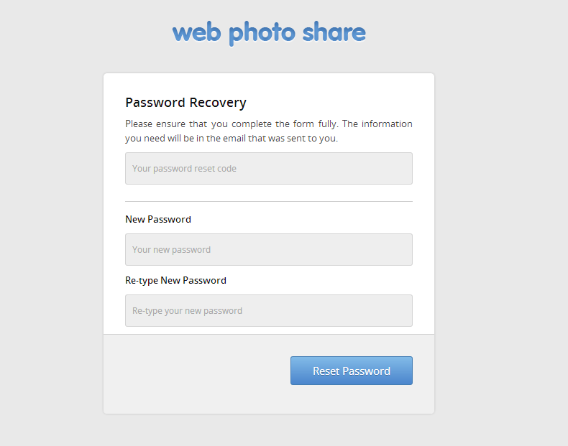

## Change Password Form

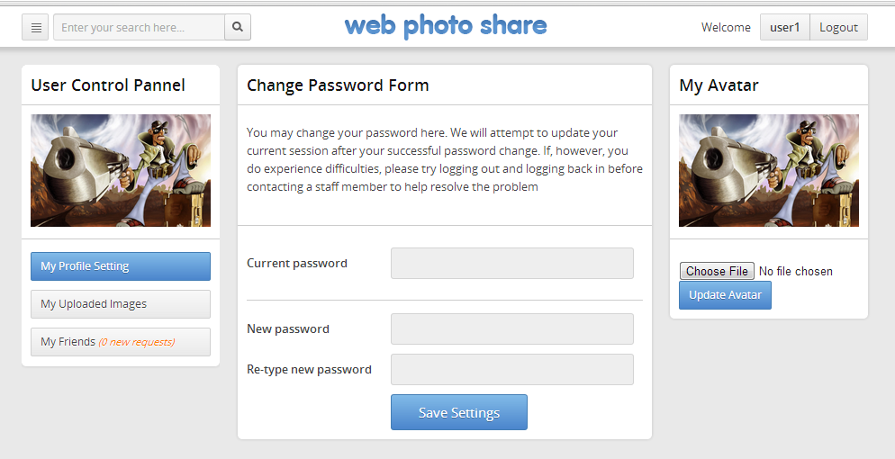

## Update Profile with Avatar

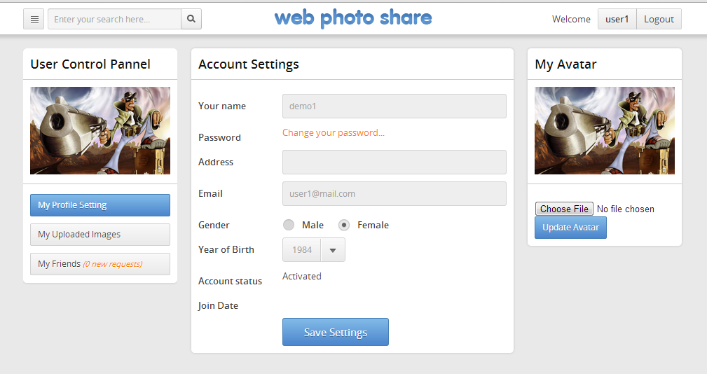

## View Collection

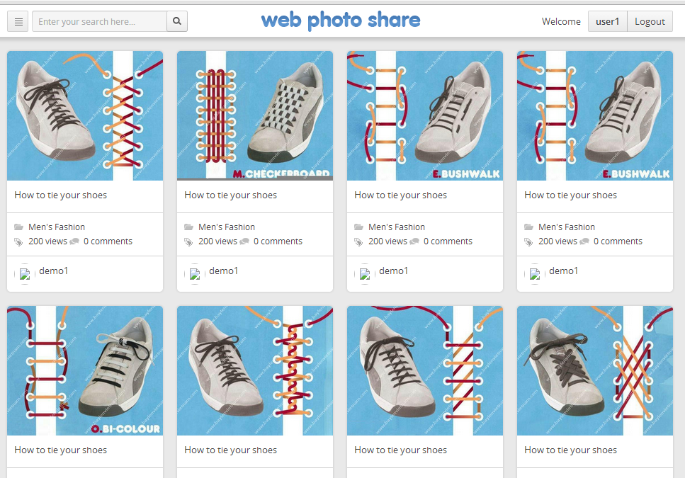

# GUI Design – Back-End

## Administrator change password form

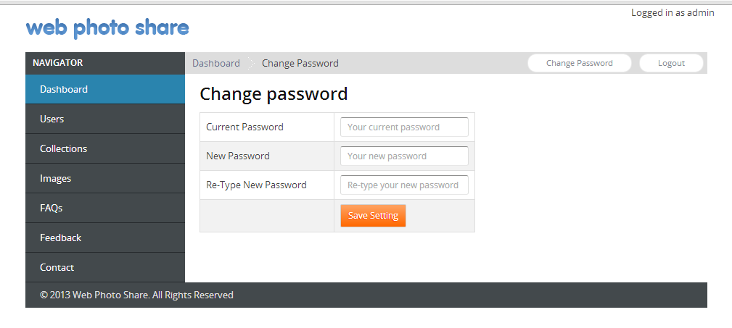

|  |  |  |
| --- | --- | --- |
|  | Prepare By: Group 1 | Approved By: Faculty |
| Date: Oct 22, 2013 | **Team Leader**  **Nguyen Vu Hung** | **Nguyen Ngo Phuoc** |